SETTING UP APPLICATION ENVIRONMENT

**Install IBM Cloud CLI**

|  |  |
| --- | --- |
| DATE | 03 NOVEMBER 2022 |
| TEAM ID | PNT2022TMID25087 |
| PROJECT NAME | NUTRITION ASSISTANT APPLICATION |

# Step 1:

Login to your IBM Cloud [***https://cloud.ibm.com/login*** and](https://cloud.ibm.com/login) in-search bar you can type

**Container registry** and click to get started.

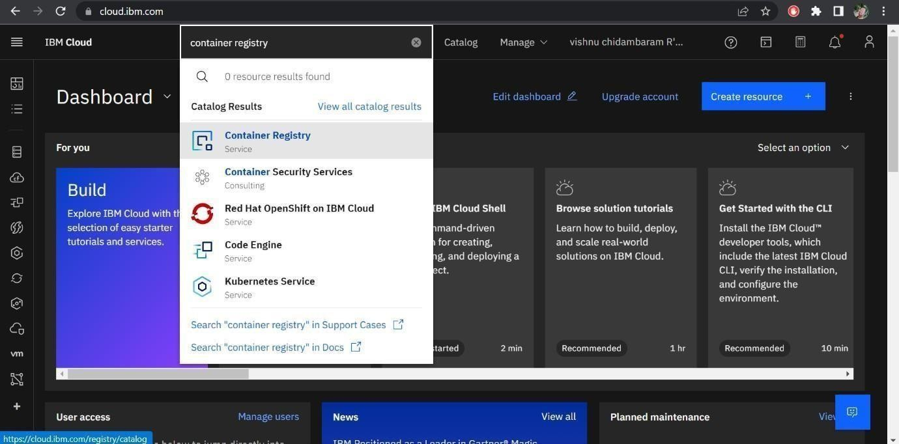

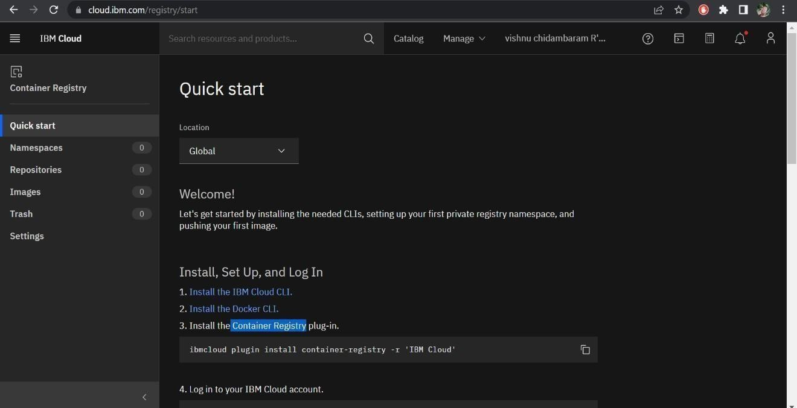

# Step 2:

Follow and do the step given in this page one by one [***https://cloud.ibm.com/registry/***](https://cloud.ibm.com/registry/%20start)

[start](https://cloud.ibm.com/registry/%20start)

# Step 3:

Run the command in power shell,

(New-Object Net.WebClient).DownloadString('https://clis.cloud.ibm.com

/install/powershell')

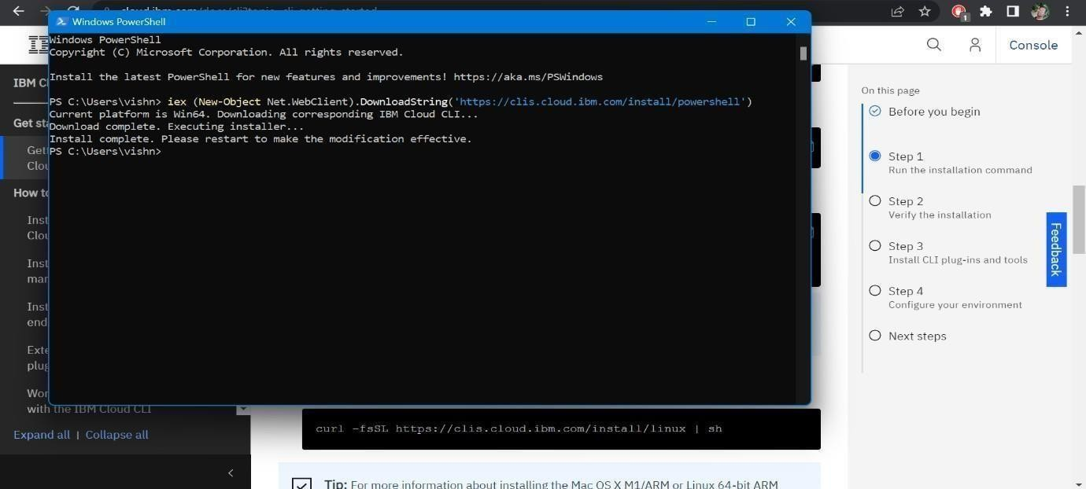

# Step 4:

Enter the command in cmd:

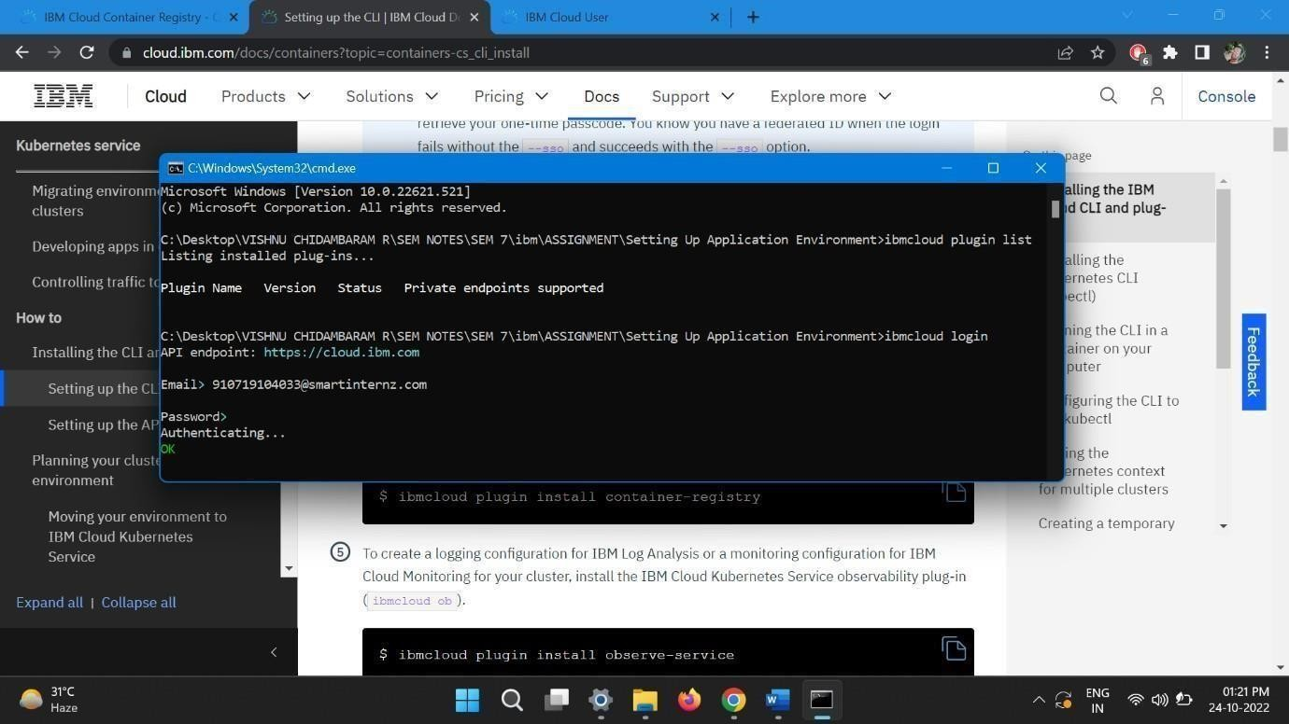

# Step 5:

Run all the command one by one in cmd

<https://cloud.ibm.com/docs/containers?topic=containers-cs_cli_install>

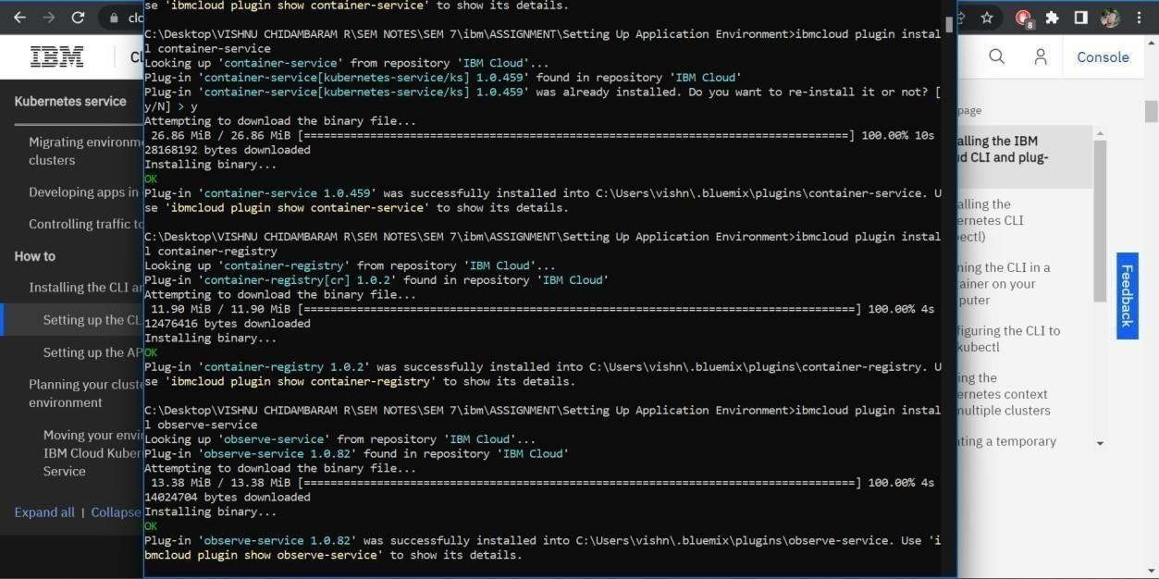

# Step 6:

Finally, you will get the IBM CLOUD CLI in your desktop